MEP August 2023 Report
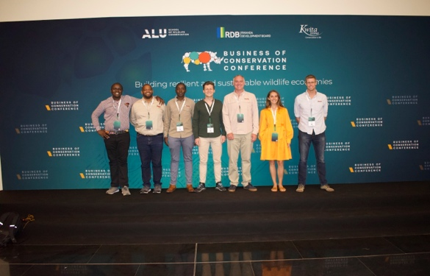

MEP took part in this year’s Business of Conservation Conference (BCC) in Kigali, Rwanda, an invitation-only event that brought together top African leaders, philanthropists, policymakers, innovators and students in the conservation space to discuss ways of investing in wildlife and their habitats to derive economic and cultural value for Africans.

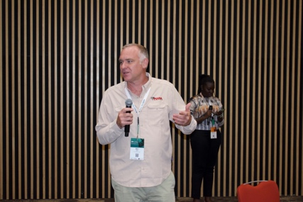
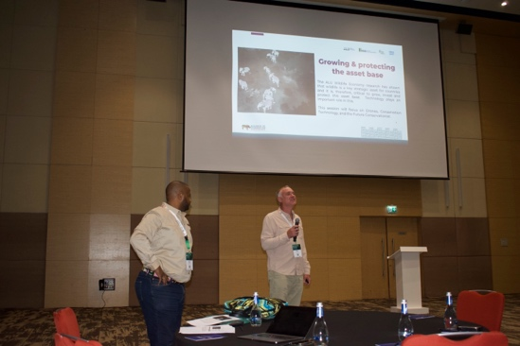
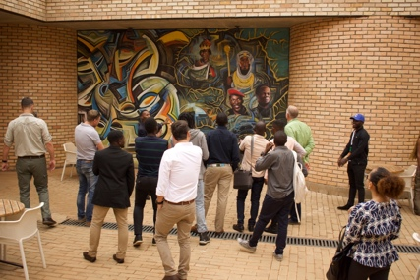
GENERAL

During the conference, MEP CEO Marc Goss and Deputy Chairman Kevin Rodrigues led a popular session that addressed how advanced drone and conservation technology training provide skills that support viable employment opportunities for men and women in or out of the conservation space. Technology plays an important role in protecting and growing the wildlife economy and MEP invests in training our rangers and researchers to use the latest technology and address threats to elephants.

“The presentation highlighted the brilliant work that MEP is doing in the Mara, integrating technology for conservation. They demonstrated that it is easy, cheap and accurate. We need to integrate technology into conservation.” Community Relations Officer at Wildlife Works Joseph Mwakima

Mara Elephant Project was honored to participate and exchange ideas with over 300 others at BCC and is committed to contributing efforts to build resilient and sustainable wildlife economies.
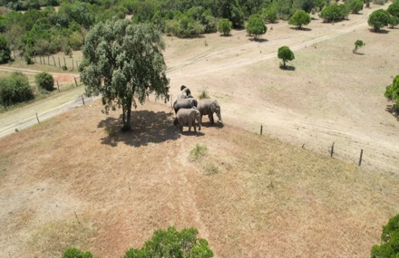
SECURITY, ANTI-POACHING & CONFLICT
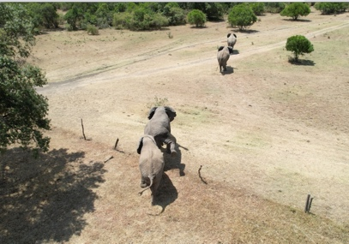
August was similar to July and saw a high number of conflict incidents. Luckily, drones are now a frequent tool for MEP rangers to rapidly respond. In August, MEP received a report from a frustrated farmer who had four bull elephants raiding his crops. MEP rangers stationed nearby immediately responded and used a drone to move the elephants out of the fenced in crops and back into the wildlife protected area.
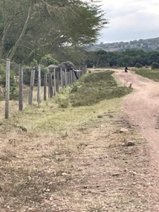
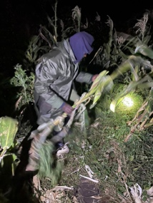
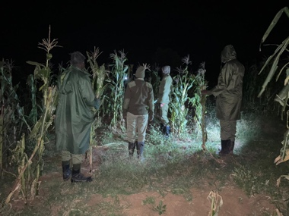
Our rangers remain vigilant in their areas of operation to protect crops which are important for livelihoods, local communities and elephants.

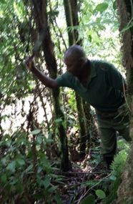
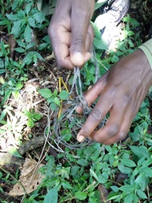
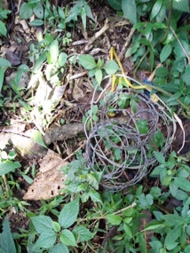
The MEP/ Sheldrick Wildlife Trust (SWT) Mau De-Snaring Unit partnered with the Bongo Surveillance Project (BSP) and Kenya Forest Service (KFS) in August to remove and destroy snares targeting wildlife for bushmeat. These snares pose a great risk to the critically endangered mountain bongo antelope and can become entangled on limbs of larger wildlife like elephants causing severe injuries and even death.
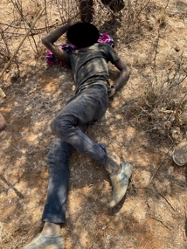
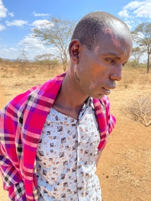
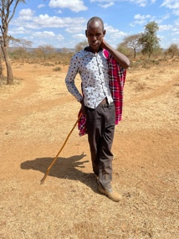
In August, the MEP “Lima” ranger team put their newly acquired skills to the test after a man was injured as a result of an elephant. Sironka was herding livestock in Mosiro with a herd of 70 elephants nearby and was injured when an elephant charged and knocked down a tree on top of him. Luckily, MEP rangers were nearby and they responded by moving elephants away from the scene and administering first aid to Sironka before transporting him to a nearby clinic where and followed up with him after he was released.
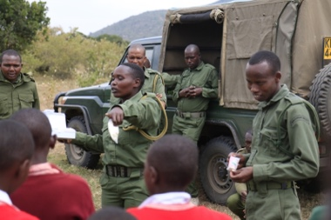
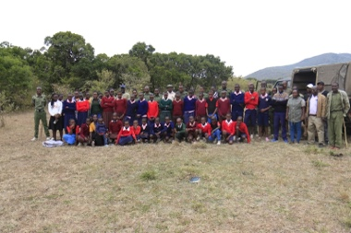
MEP rangers not only act as wildlife protectors but also community ambassadors committed to promoting co-existence. In August, they participated in a community meeting to highlight their work, promote co-existence and inspire the next generation of Kenyan conservationists in attendance.
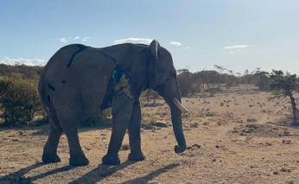
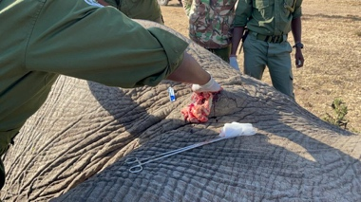
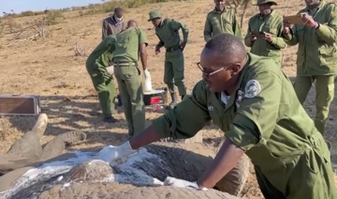
In late August, the MEP mobile ranger team came across an injured bull elephant during their routine patrol. The team immediately called in Kenya Wildlife Service (KWS) Vet Dr. Njoroge from the SWT Mobile Vet Unit to treat him for a spear wound on his right leg.
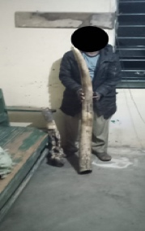
Overall, in August, MEP rangers alongside government partners arrested one ivory suspect, four bushmeat poaching suspects and seven habitat destruction suspects. They confiscated 21 kg of ivory and 200 kg of bushmeat and removed 21 snares. They also confiscated 34 pieces of timber and 51 posts and destroyed 16 charcoal kilns. As we mentioned, MEP ranger mitigated 42 conflict incidents, just one less than July. In August, MEP rangers covered a distance of 3,136.9 km on foot and patrolled 17,692 km by car in the GME.

HELICOPTER
On August 20, MEP celebrated World Helicopter Day and we highlighted the importance of the MEP helicopter, a vital tool that we use for aerial reconnaissance, wildlife monitoring, rapidly responding to mitigate conflict or in an emergency airlifting people for immediate medical treatment. In fact, in August, the helicopter was deployed to rapidly respond to move elephants out of farms, provide aerial assistance during elephant treatments and to airlift a community member injured by an elephant to the hospital.
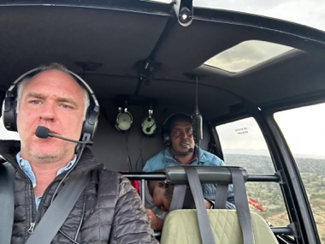
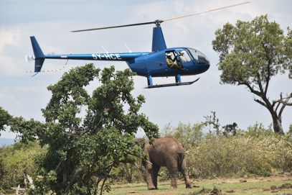
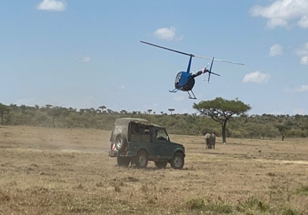

COMMUNICATIONS & FUNDRAISING
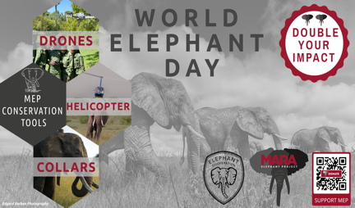
In August, MEP celebrated World Elephant Day and thanks to your support, we raised $25,000 to support the use of drones, the helicopter and elephant collars to mitigate conflict. MEP released the second quarter newsletter, MEP matters, in August and you can read it here.

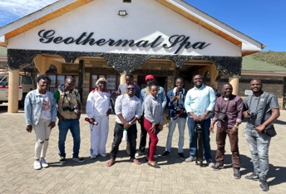
MEP Communications Officer Dibblex Lesalon participated in 3-day photography workshop hosted by Wildlife Direct and led by renowned photographer Jeroen Swolfs. The workshop focused on using smartphones to capture compelling images. Dibblex is sharing these skills with MEP rangers and researchers to capture the incredible stories they love every day while protecting Kenya’s wildlife and wild spaces.

Elephant Cooperation continued their commitment to supporting MEP’s drone program with a grant to purchase a new drone to mitigate conflict. We’ll be deploying the Elephant Cooperation drone to increase elephant protection soon. Mara Elephant Project Trust in Kenya received $6,567 in donations in the month of August. Thank you to Kicheche Camps, The Maa Trust and Ol Tome Safaris for your support. Mara Elephant Project USA received $273,939.40 in support of MEP’s efforts. Thank you to Elephanatics Conservation Education and Mary Fuller, Mey Share Foundation, Michael & Margaret McCormick, Marian Weaver, the Ann and Gordon Getty Foundation, the Lucia Charitable Foundation, Carol Staton, Michael Kelley, Randol Bartsch, Mike Karpen, Therese Mattal, Sue Anschutz-Rodgers, Margaretta Taylor, Nancy Meyer, Ginni Keith, Mason Williams, Debra Shearer, Linda Mayer, Curtis Collins, William Van Buren, Sandra Bass, Gwendolyn Binder, Gerald Black, Carmen Cappadona, Sally Davidson, Michael Donnelly, Deborah Fagas, Caroline Gabel, Ann Gaillard, Gail Glasser, Gregory Kunert, Richard Litkenhaus, J Martin, Dennis Monroe, Kay Murray, Roger Pasarow, Douglas Philip, Walter Richardson, Caryl Rine, Margarita Romano, Charles Shuman, Susan Wiener and Allen Wise.

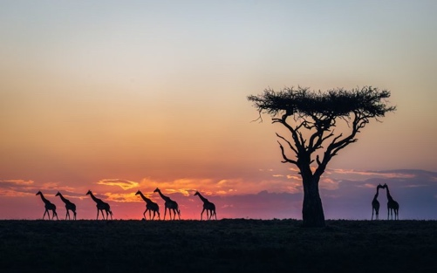

There were 17 entries in August in the Greatest Maasai Mara photo competition that supported MEP. Thank you to all the photographers who supported us. Left, an entry from Kunal Shah.

RESEARCH & CONSERVATION
Director’s Update
The R&C department had a lot of activities in in August. Firstly, I welcome Francis Odero & Eugene Kuloba to the MEP team. Both have strong geospatial skills and will be helping with data analyses at MEP. We hosted Lydia Tiller from the Amboseli Trust for Elephants to help with collar data summaries and training on EarthRanger. Ray Rao has produced a beta-version of the Ecoscope Downloader software – a graphical user interface that leverages the EarthRanger downloading functionality in our Ecoscope python library. I also engaged with Nimble Gravity developers to help with the ongoing development needed for Ecoscope. The library has come a long way recently. At the end of August, I travelled to Rwanda to attend the Business of Conservation Conference. My main take-away was how we need to better develop training programmes in conservation data analytics and provide further career opportunities for data-literate students in conservation.

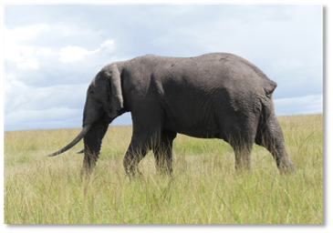
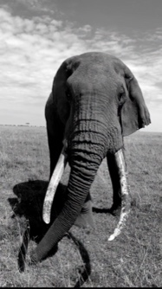
In August, The MEP long-term monitoring (LTM) team monitored individual 2 from the MEP identified elephant database, ElephantBook. This bull elephant, known internally as Flopsy, has two distinguishable characteristics, he has no tail, and his left ear is floppy.

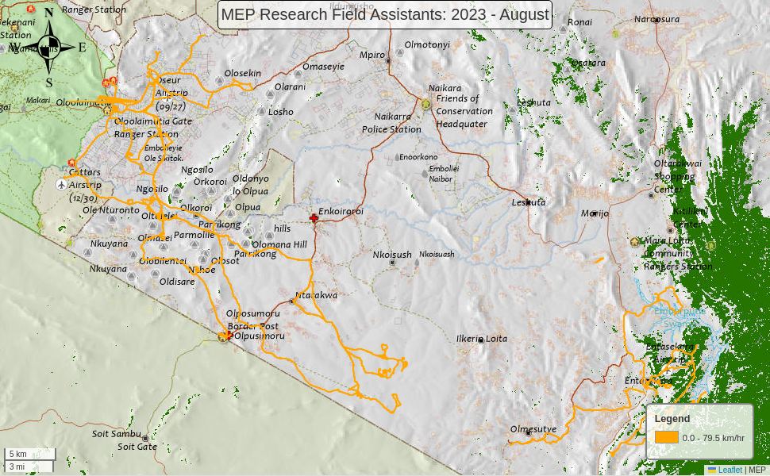
Movements (orange tracks) of MEP’s two field assistants during August. All of our field assistants are working on mapping fences, roads and landcover ground-truthing points using motorbikes and our TerraChart app. They recorded 56 km of fences and 34 LCC points in August.

MEP Co-Existence Farm
General Update
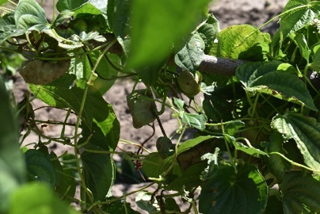
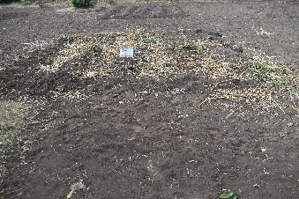
Rainfall in the month of August occurred only once with very minimal amount of water received. The recently introduced crops had to all be irrigated to ensure they grow due to the droughts in the area. We had a few guests this month. A team from Uvumbuzi visited and filmed the farm in the beginning of the month, their work is to promote youth work in conservation through filming in Kenya. We also hosted the TVAgro team from Colombia visiting the farm also showcasing the importance of agriculture in Kenya especially in conservation areas and the promotion of coexistence.
Yam Plant with Yam fruits
Gooseberry predated by hippos

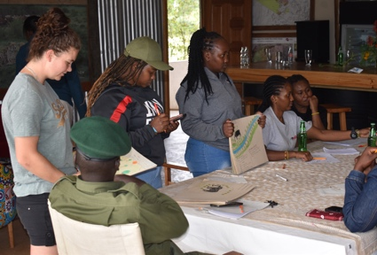
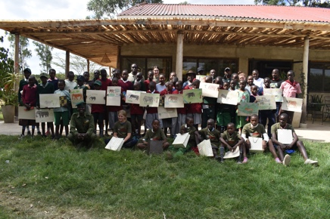
The MEP Co-Existence team celebrated World Elephant Day with conservation clubs from five local schools. The students learned more about elephants and together with Enoonkishu Conservancy we had an elephant drawing competition. Conservation clubs remain an important element of coexistence between wildlife and the communities as the pupils play a big role as ambassadors of conservation and in relaying information to their parents. We want to thank Kampur Travel Diaries for supporting our conservation education initiatives.

Co-Existence Farm SITREP: August 2023
Date Time | Plot ID | Type of crop | Detail
2023_08_05 | 1-2.1 | Lemon Grass | Hippos predated on all the lemon grass growing in this plot
2023_08_05 | 2-12.2 | Goose Berry | Vervet monkey eat the growing fruits in the plots of gooseberry
2023_08_05 | 1-3.1 | Sukuma | Replanted for the fifth time, after it was predated by various wildlife including vervet monkey and hippos
 | 3-11.1
 | 7-1.1
 | 9-4.1
 | 11-9.1
2023_08_05 | 1-7.2 | Canola | Replanted for the fourth time after it was predated by hippos and some harvested
 | 6-2.2
 | 8-5.2
 | 9-12.2
 | 11-1.2
2023_08_05 | 2-2.2 | Turmeric | Introduced to the farm and planted for the first time
 | 4-4.2
 | 7-8.2
 | 8-16.2
 | 9-11.2
2023_08_05 | 2-7.1 | Beetroot | Planted for the first time
 | 3-10.1
 | 7-2.1
 | 10-3.1
 | 11-12.1
2023_08_05 | 3-1.2 | Eggplant | Replanted for the fourth time, the previous crop was predated on by elephants
 | 4-9.2
 | 7-5.2
 | 10-5.2
 | 11-11.2
2023_08_05 | 3-4.1 | Managu | Managu is replanted, this is the fifth replant and the final, the last crops were predated on by elephants
 | 4-8.1
 | 6-12.1
 | 8-15.1
 | 11-10.1
2023_08_05 | 3-5.1 | Sage | Sage has been planted for the first time replacing cabbage
 | 5-8.1
 | 6-15.1
 | 8-11.1
 | 11-14.1
2023_08_05 | 2-12.2 | Goose Berry | After predation by vervet monkey and hippos, goose berry crop has been replanted for third time
 | 5-5.1
 | 7-14.2
 | 8-2.1
 | 6-9.1
2023_08_15 | S2-1-2.1 | Maize/Chili/cover crop | Maize has been replanted in all the plots, all maize previously in the plots were uprooted and eaten by helmeted guinea fowl and vervet monkeys
 | S2-1-3.1 | Maize/Sunflower/cover crop
 | S2-1-4.1 | Maize/Ditch
 | S2-1-5.1 | Maize/Chili/intercrop
 | S2-1-6.1 | Maize/Sunflower/intercrop
2023_08_20 | 1-10.1 | Tomatoes | All the plots of tomatoes have been replanted for the fifth time
 | 5-13.1
 | 8-9.1
 | 9-3.1
 | 11-6.1
2023_08_15 | 1-3.1 | Sukuma | The vervet Monkey uprooted and eat the recently planted Sukuma plants
 | 9-4.1
2023_08_15 | 8-2.1 | Goose Berry | Hippos predated on the gooseberry plot
2023_08_22 | 3-6.1 | Lemon Grass | Hippos predated on the plot with lemon grass
2023_08_22 | 6-3.2 | Yams | Goats entered the farm and eat he green leaves of yam plot
2023_08_31 | 2-2.2 | Turmeric | Hippos predated on the recently planted turmeric
2023_08_31 | 2-4.2 | French Lavender | Hippos passed through the plot with French lavender zero predation observed
2023_08_31 | 5-12.1 | Peppermint | Hippos cleared the three plots of peppermint by eating the plants
 | 2-1.1
 | 3-8.1
2023_08_31 | 3-10.2 | Beetroot | Vervet monkey uprooted all the recently planted plants
2023_08_31 | 3-11.1 | Sukuma
2023_08_31 | 3-4.1 | Managu
2023_08_31 | 4-8.1
2023_08_31 | 10-1.1 | Lemon Grass | Hippos eat part of the plot with lemon grass

Climate Report
Table 2: 1 MEP’s Experimental Farm Rainfall Recording August 2023
Date Time | Precipitation
 | Rain gauge 1 (ml) | Rain gauge 2 (200m2)
2023_08_26 | 4 | 2.5

ENVIRONMENT: NDVI
Greater Mara Ecosystem (GME)
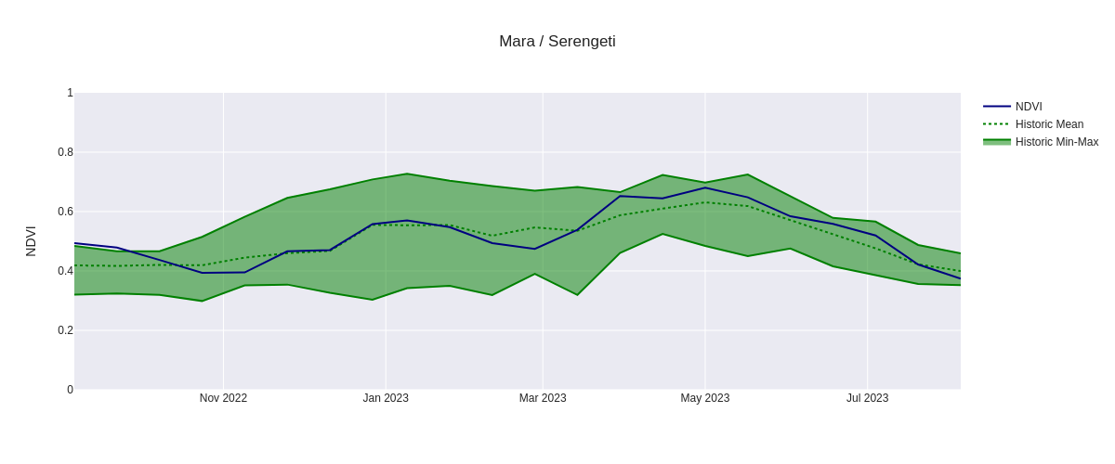
Mau Forest
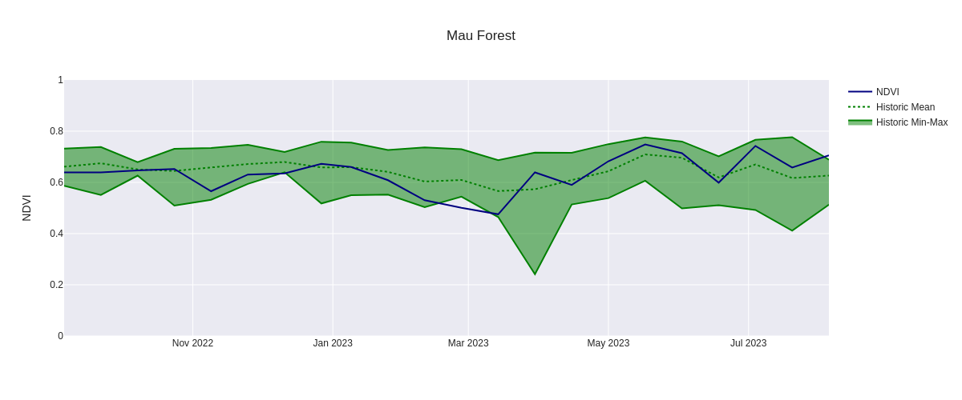
Rift Valley / Mosiro
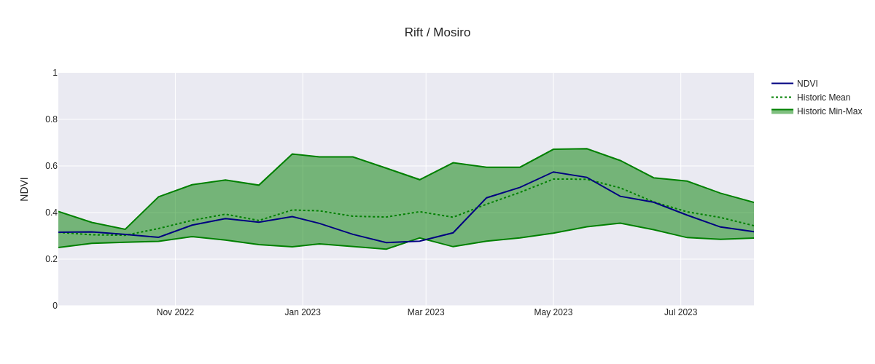

Marmanet Forest
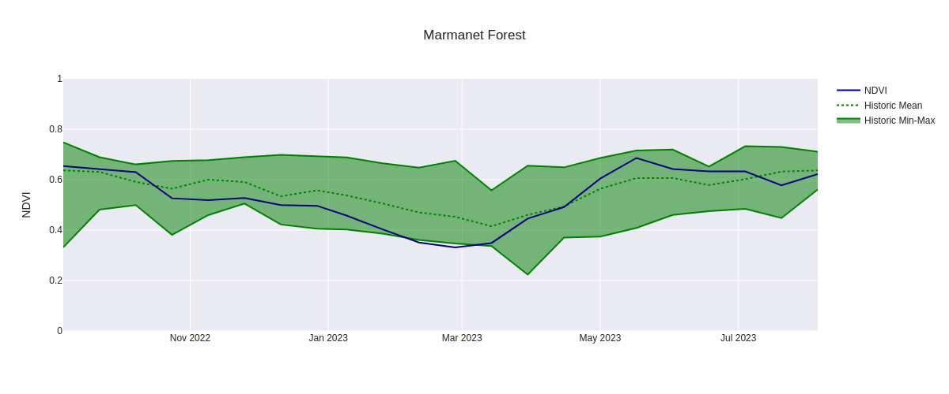
Nyakweri Forest
