MEP February 2023 Report
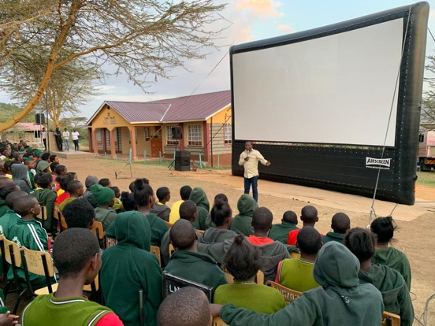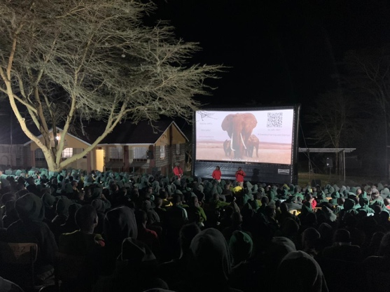
The Elephant Queen Outreach team brought the movie and play to audiences in the Mara in February. MEP Assistant Senior Warden Jackson Maitai participated in the discussion with both adults and children alike.

GENERAL
Mara Elephant Project acts as first responders to both the people and wildlife in the ecosystem, both on land and, sometimes, in the water. Many of MEP’s community rangers and researchers operate near water and in February, they had the opportunity to participate in a Waterborne Assisted Recovery Training given by Focused Conservation. The one-day course covered search and rescue procedures and water safety. Thank you to Focused Conservation for conducting the training and the Mara River Lodge for the use of their pool. All MEP staff graduated with their water safety certificate.

“It was one of the more exciting trainings I’ve done at MEP. I learned a lot and had fun, kayaking for search and rescue, water safety procedures and much more. I’m glad I got the opportunity to do it.” Research Assistant Caroline Kagume

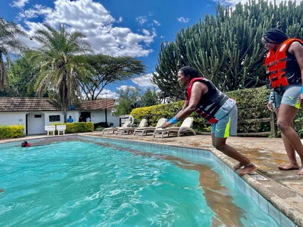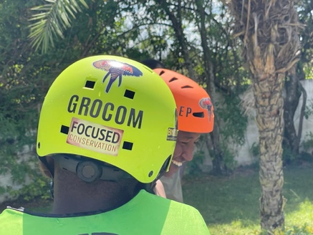

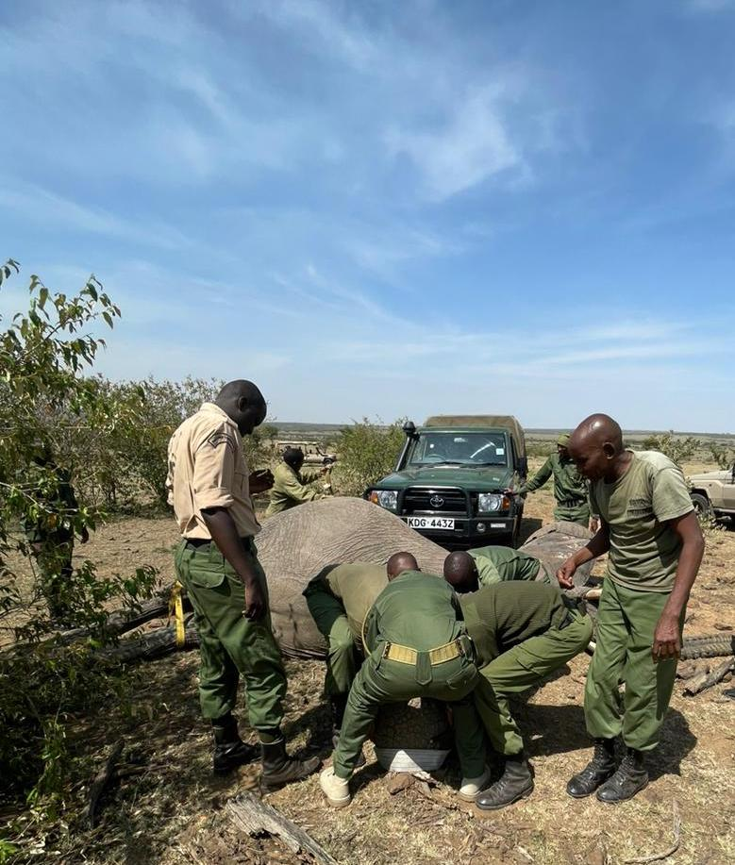
While monitoring elephants, the MEP mobile ranger team noted a female that appeared to have an injury on her side. After consulting with the Kenya Wildlife Service (KWS) Vet Dr. Ndambiri from the Sheldrick Wildlife Trust (SWT) Mobile Vet Unit, a treatment operation was coordinated on February 26. This female was previously identified by MEP and is individual #201. The stomach injury, most likely a result of a spear, was treated in Naboisho Conservancy and she’ll continue to be closely monitored while she’s healing.

SECURITY, ANTI-POACHING & CONFLICT
Over one day in February, MEP’s mobile, echo and foxtrot ranger teams all removed snares in their various areas of operation. Our community rangers are committed to wildlife protection.

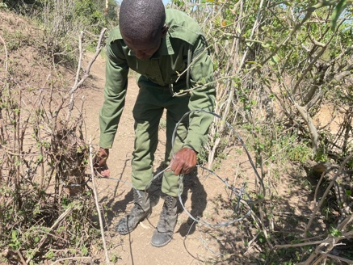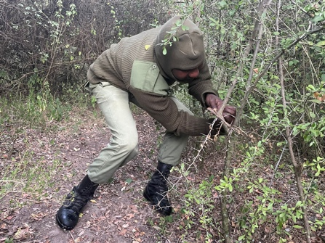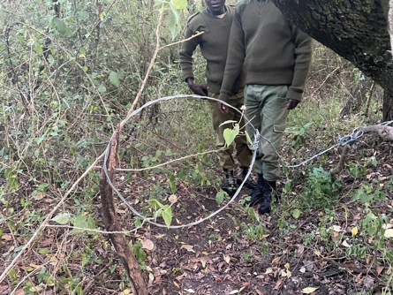

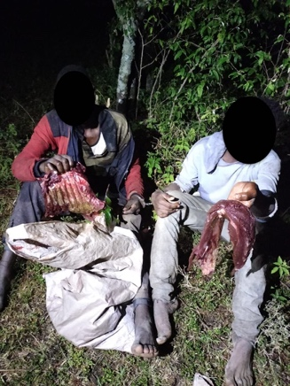
On February 25, the MEP “Foxtrot” ranger team joined KWS and Enonkishu Conservancy rangers to set up an ambush to catch bushmeat poachers. They successfully arrested two suspects, confiscated nine arrows, two bows, 11 snares and 5 kg of bushmeat.

During the first of February, fires broke out in the Mau and Loita forests. The two MEP/SWT Trust Mau De-Snaring Units joined the community to combat the fire that consumed 70-80 hectares. They were able to create a fire line to stop its progress and nightly rains helped extinguish the bulk of the fire. Meanwhile, the “Bravo” team in the Loita Forest was doing the same. The MEP helicopter was called in to assess the damage and Kenya Forest Service joined. Nightly rain helped the team, and luckily, five days after it started, the fire was out.

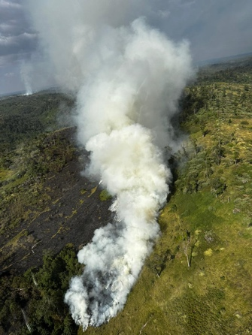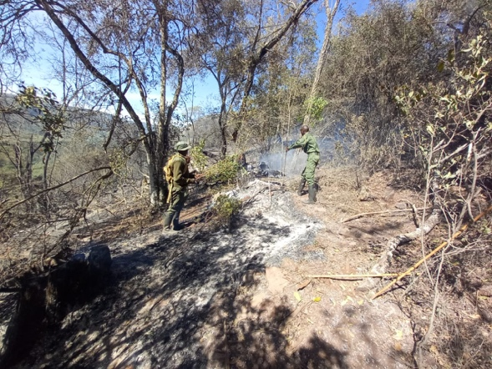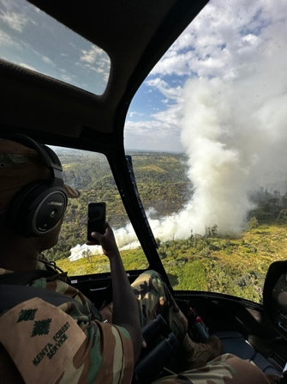

The MEP “Kilo” ranger team is the most recent team to be deployed to increase protection of the Loita Forest. In late February, they discovered 500 posts logged from the forest inside a fence and joined the MEP “Bravo” team and government partners to set up an ambush to arrest the culprit. It took several days of patience, but the ambush was finally successful, and they arrested one suspect and booked him at the nearby police station.

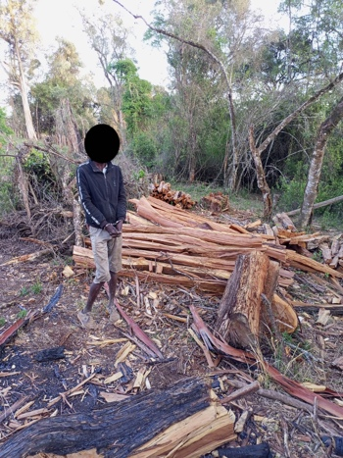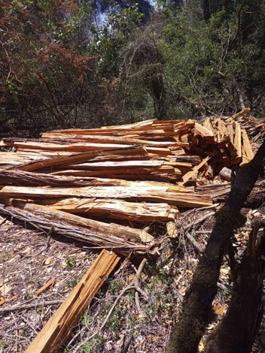

Overall, in February, there were four bushmeat poaching suspects arrested alongside government partners, 5 kg of bushmeat confiscated, and 42 snares removed. There were 9 habitat destruction suspects arrested alongside government partners, and 554 pieces of timber and 546 posts confiscated. MEP rangers destroyed 21 charcoal sacks and 30 kilns, they also mitigated 12 conflict incidents. In February, MEP rangers covered a distance of km 1825.72 on foot and 14690.42 km by car in the GME. MEP rangers covered a distance of 113.92 km on foot in Marmanet.

HELICOPTER
On February 8, a herd of elephants was trapped inside fences within community land. While elephants can easily move through fences, they are sometimes hesitant especially with young calves in tow. The MEP “Foxtrot” ranger team responded to push the elephants out of the fences, and spent all day trying to move them out, and weren’t able to convince them from the ground. That’s when the MEP helicopter was called in as a last resort to push them through the fences and back into the safety of a conservancy. MEP rangers joined by our Senior Warden coordinated the effort from the ground while CEO Marc Goss was in the air. He successfully moved the first group of elephants through the fence and back to safety, then had to go back for a mom and two calves. It was amazing to see the mom navigate her family along the same path the other elephants had taken ensuring they were joined together again. While the helicopter is always our last resort, it’s an important tool used alongside our rangers on the ground to rapidly respond to situations where elephants and people meet.

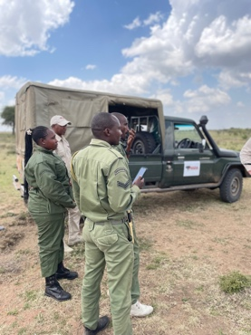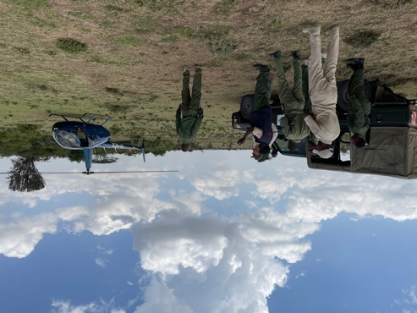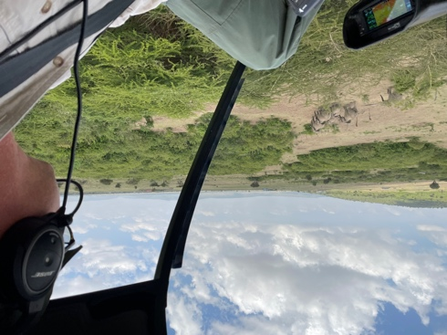
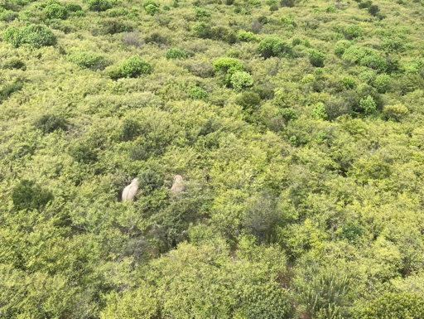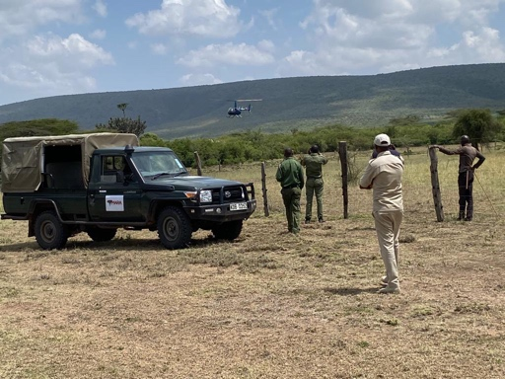
On February 9, alongside KWS Vet Dr. Ephantus Ndambiri, a bull elephant was fitted with a collar in the Olderkesi area in order to monitor his movements along the Sand River. The bull was named “Matumaini” or “Hope” in Kiswahili, the perfect name for him as he will give KWS, WRTI and MEP hope that we can protect this corridor. CEO Marc Goss piloted the MEP helicopter while the MEP mobile ranger team was on the ground. They’d spent a month scouting for this elephant through tough terrain, and he was found inside an area with dense brush. Thanks to everyone’s efforts, the collaring operation was a success, and we can now track this elephant’s movements alongside our partners to increase protection for him, the community and the place they both call home.

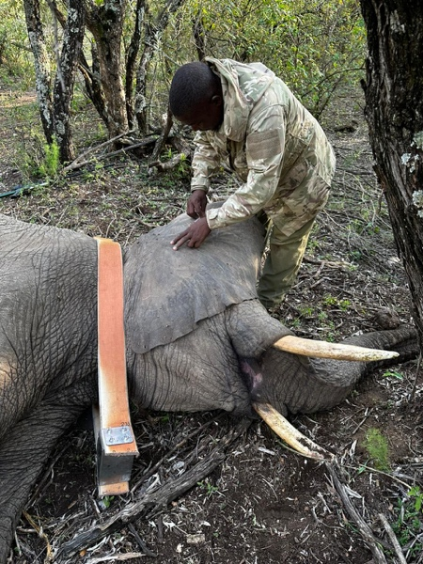

COMMUNICATIONS & FUNDRAISING
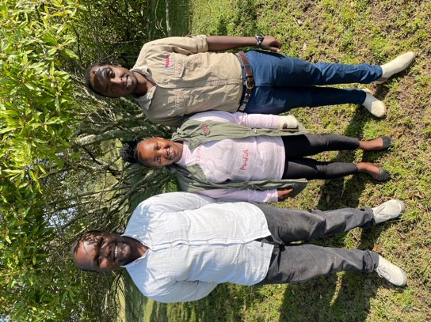
Thank you to Dibblex Lesalon from Boots on the Ground Podcast for joining us at MEP headquarters in February to interview Conservation Officer Wilson Sairowua and the head of our co-existence department Abigael Pertet for two upcoming episodes. The podcast aims to amplify voices for conservation and their episodes, both airing in March, will center around MEP’s community approach to conservation.

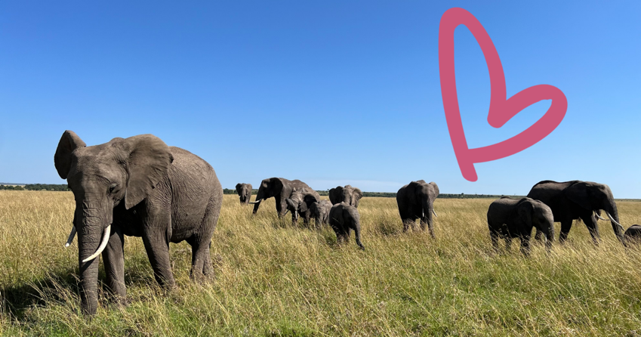
Thank you for everyone who gave elephants a ton of love on Valentine’s Day. We’re extremely grateful.
In February, the Sidekick Foundation, Inc. d/b/a Mara Elephant Project USA received $108,960.41 in donations to support the efforts of Mara Elephant Project in Kenya. The Mara Elephant Project Trust received $7,193. Thank you to Kapoeta by Ambica for her support, she’s raising money for MEP through her jewelry sales. Additional thanks to Foreningen Forsvara Elefanterna, a long-time supporter of MEP for February support. Thank you to the Eilish Neff, IFG Foundation, Laurie Raymond, Mark Pahuta, Carol Arbury, Elizabeth Peyton, Janet Murphy, Curtis Collins, Sally Davidson and Louise McGregor for supporting MEP in February. We also received the final grant installment from the Indianapolis Zoological Society, and we’re grateful for their long-time support.

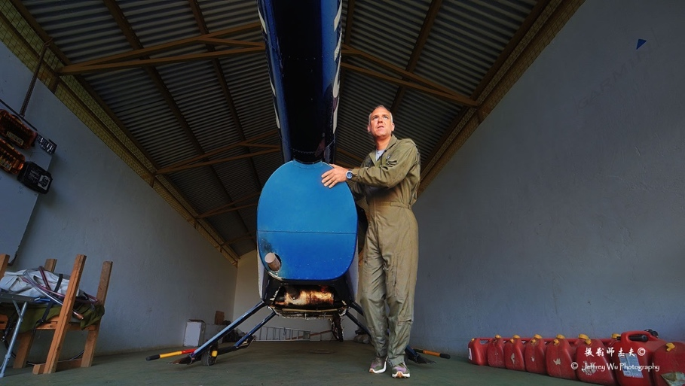
Finally, MEP wanted to thank Tutima, a German watch brand known for high-end durable watches perfect for adventure. Tutima is supporting MEP and featuring CEO Marc Goss in their ad campaigns shot by MEP Image Ambassador Jeffrey Wu.

RESEARCH & CONSERVATION
Director’s Update
We had several visits in February. First, I spent time with Holly Dublin and Cindy Obath working on the ‘monitoring framework’ project that we have undertaken as part of our collaboration within the ‘One Mara Research Hub’. The framework we are developing is conceptual and based on consultations with other researchers and managers across the Greater Mara. We are looking to finalize this work by the end of April. Next, we hosted Jeremy Goss and Ben Kiptoo from Big Life to discuss approaches to conservation data collection and analysis. In particular, we discussed approaches to the use of EarthRanger and spatial mapping. Big Life is interested in employing some of the conservation technology that MEP has been developing including our Ecoscope tools and TerraChart/landDx. We also hosted Purity Milgo from Save The Elephants for two weeks to provide training on Ecoscope. We are hoping this software tool will facilitate data retrieval and analysis for a wide range of users and organizations and improve conservation impact.

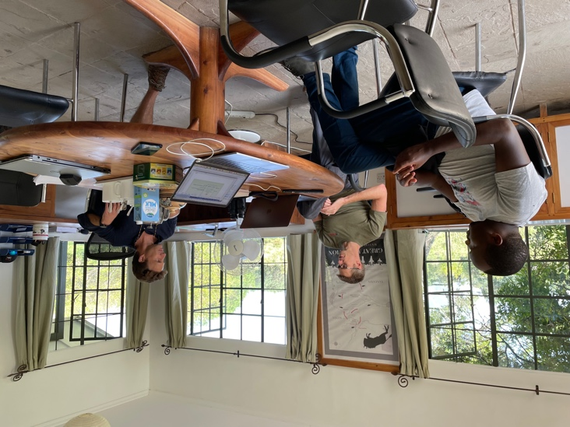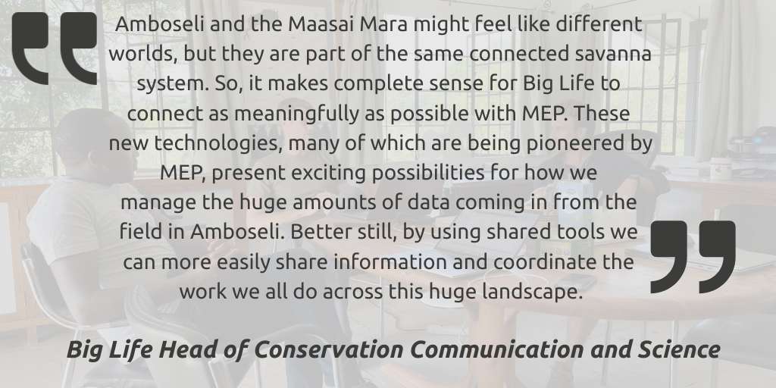

In February, MEP’s Wilson Sairowua monitored individual 28 in Mara North Conservancy to check in on how he’s healing after being treated for an arrow wound in 2022. He was one of three elephants treated on the same day for conflict-related wounds and it not only appears that the wound has healed, but also that he hasn’t sustained anymore since then. We continue our monitoring efforts to increase protection for the elephants that call the Mara home.

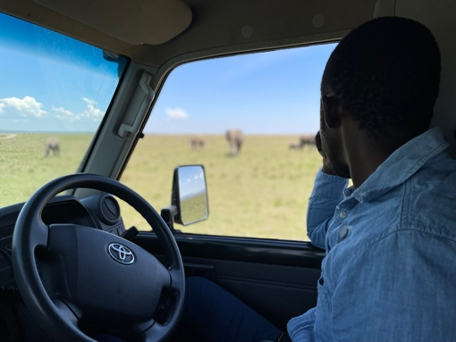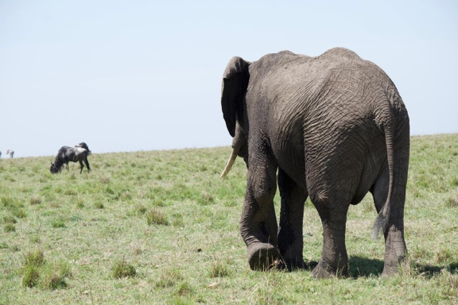

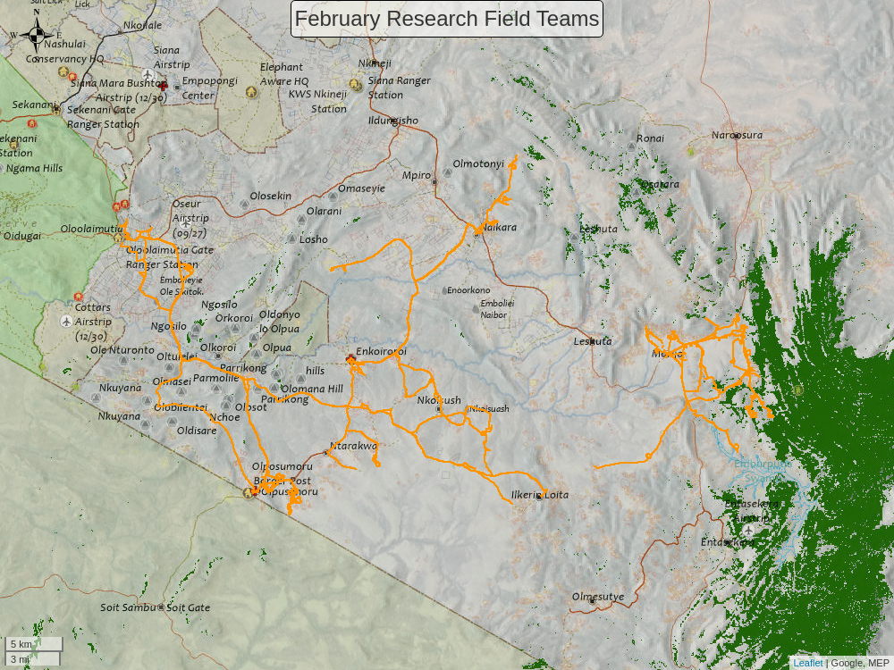
Movements (orange tracks) of MEP’s two field assistants during February. All of our field assistants are working on mapping fences, roads and landcover ground-truthing points using motorbikes and our TerraChart app. They recorded 1.30 km of fences and 12 LCC points in February.

MEP Co-Existence Farm
General Update
February started with low rainfall levels, and we eventually experienced the lowest river levels since we started the project in this area. Luckily rainfall increased later in the month. This month elephants visited the farm twice, with the second group of 13 elephants accompanied by five calves eating most crops as well as destroying structures. For the first time, we also have baboons crossing over the river and eating the garlic, which was one of the crops that had been previously identified as having zero predation for the last two years. A swam of caterpillars infested the farm and the whole of the Maasai Mara region but thankfully they mostly ate grass and a few of the broad leaf plants. This month the farm did not receive visitors, but we were featured in the Boots on the Ground Podcast by Dibblex Lesalon. The team is starting the economy study and Abigael visited the Nature Oil Company located at Enoonkishu. They produce large hectares of tea tree, which is one of the crops doing well at the farm. We plan to stay in touch and hopefully collaborate in the future to understand the economics of the less predated crops in the farm.

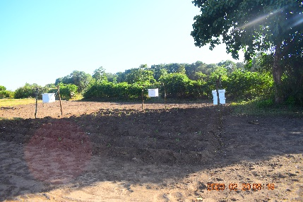
A new beehive fence installed on the farm.

Experimental Farm SITREP: February 2023
Date Time | Plot Id | Type of Crop | Details
2023_02_08 | 1-7.1 | Canola | A swam of caterpillar fed on most of the broad leaf plants including canola
2023_02_08 | 3-6.1 | Lemon Grass | A few strands of lemon grass were eaten by hippos
2023_02_08 | 3-11.1 | Sukuma | Caterpillar fed on the leaves of Sukuma in this plot, being close to the fence
 | 7-1.1
2023_02_08 | 5-3.1 | Carrot | Hippos uprooted and eat a few lines of the carrot crop
2023_02_08 | 6-3.1 | Potatoes | Hippos passed through the plot, stepped and uprooted a few potato crops
 | 9-6.1
2023_02_08 | 7-3.1 | Chili | Hippos passed through this plot, a few of the growing chili crops were uprooted and eaten
2023_02_08 | 8-5.2 | Canola | half of the plot eaten by hippo
2023_02_08 | 9-1.1 | Butternut | Elephant cleared by eating and stepping on this plot
2023_02_08 | 1-4.1 | Sweet Potato | All the sweet potato plots have been replanted after they were predated on by elephants and hippos
 | 5-1.1
 | 6-6.1
 | 10-8.1
 | 11-13.1
2023_02_08 | 6-14.1 | Corriander | They were replanted after harvesting an clearing after overgrowing
 | 7-9.1
2023_02_08 | 5-9.1 | Carrot | They were replanted after the harvest the previous month
 | 8-13.1
2023_02_08 | 9-17.1 | Onion | Onions in this two plots were replanted, this is their forth trial after they were harvested
 | 8-1.1
2023_02_08 | 6-12.1 | Managu | A total of 7kgs of Managu leaves were harvested in the three plots and average of 2kgs from each plot
 | 4-7.1
 | 8-15.1
2023_02_12 | 1-5.1 | Chili | A few crops fell after elephant passed through the plot
2023_02_12 | 1-12.1 | Garlic | Elephants stepped on the plot though no predation
2023_02_12 | 1-13.1 | Okra | Okra has been eaten and uprooted by hippos, leaving very few
 | 6-5.1
2023_02_12 | 2-3.1 | Cucumber | All the cucumber crops were eaten by elephants and destroyed, a few were left on the ground and were later harvested
 | 5-7.1
 | 10-10.1
 | 9-8.1
2023_02_12 | 2-5.1 | Carrot | The three plots were vandalized by elephants and eaten
 | 5-3.1
 | 7-6.1
2023_02_12 | 2-8.1 | Potatoes | Elephant stepped and passed through the plot
 | 7-12.1
 | 9-13.1
2023_02_12 | 3-1.2 | Eggplant | Hippos have eaten tips of the eggplant crop leaving few to regrow
 | 4-9.1
2023_02_12 | 3-4.1 | Managu | The elephants trodden and eat Managu crops
 | 4-7.1
 | 8-15.1
2023_02_12 | 4-10.1 | Butternut | Elephant stepped and eat all the crops in the three plots
 | 5-11.1
 | 6-7.1
 | 11-4.1
2023_02_12 | 5-13.1 | Tomatoes | Elephants stepped on the young tomato crops breaking a few
2023_02_12 | 8-5.2 | Canola | Hippos destroyed by eating and stepping on this plot
 | 9-12.2 |  | The canola plot was partially eaten by elephants
2023_02_12 | 8-8.1 | Onion | Elephants for the first time predated on onion, they uprooted and eat all the crops in this two plots
 | 10-4.1
2023_02_12 | 8-16.1 | Spinach | Elephant passed through the plot and stepped the growing plant
 | 9-11.1
2023_02_12 | 11-9.1 | Sukuma | Hippos eat the growing Sukuma plants
2023_02_12 | 11-10.1 | Managu | Hippos fed on the Managu crop
2023_02_12 | S2-1-4.1 | Maize/Ditch | Elephant jumped over the ditch and eat the growing maize crop
2023_02_12 | 1-7.1 | Canola | The crop was replanted for the fourth time after it was predated on by hippos and elephants
 | 8-5.2
 | 9-12.2
2023_02_12 | 1-11.1 | Onion | It was replanted for the fourth time, it has had stunted growth for a long time
2023_02_12 | 2-7.1 | Sunflower | It was replanted after only a few emerged after long period of drought while in the ground
 | 7-2.1
 | 10-3.1
 | 11-12.1
2023_02_12 | S2-1-1.1 | Maize/hives | For the fourth time the maize were replanted after placing the hive fence on
2023_02_12 | 6-3.1 | Potatoes | A total of 2kg of potatoes were harvested after they were predated before reaching maturity
 | 9-6.1
2023_02_12 | 7-6.1 | Carrot | After predated on by elephant the remaining were harvested a total of 11kgs
2023_02_12 | 8-4.1 | Corriander | 23kgs of Corriander which had surpass maturity was harvested to allow a replant
 | 10-2.1
2023_02_12 | 9-8.1 | Cucumber | 9kgs of cucumber fruits were harvested, this is after elephants vandalized the plot, the few remaining were collected and the above was the total yield in two plots
 | 10-10.1
2023_02_19 | 7-2.1 | Sunflower | The common black bird fed on the growing sunflower seeds
2023_02_19 | 7-8.1 | Spinach | Hippos passed through the plot, eating the growing spinach leaves
 | 9-11.1
2023_02_19 | 9-12.2 | Canola | Hippos eat the remaining canola crop
2023_02_19 | 2-10.1 | Corriander | A total of 8kgs of Corriander was harvested from the plot after it had overgrown
2023_02_19 | 7-3.1 | Chili | 4kgs of red chili were harvested from this plot
2023_02_27 | 2-2.2 | Spinach | Hippos passed through all the plots eating the leaves of the regrown spinach plant leaving very few in each plot
 | 4-4.1
 | 8-16.1
 | 9-11.1
2023_02_27 | 2-6.2 | Geranium | Hippos passed through the plot, breaking a few crops
2023_02_27 | 4-3.1 | Garlic | The baboons visited the farm for the first time, uprooting and eating the bulb part of the garlic crop
 | 8-6.1
2023_02_27 | 4-9.1 | Eggplant | Hippos have been passing through the eggplant plots and eating the leaves by the tips leaving small stalks to regrow
 | 10-5.2
 | 11-11.2
2023_02_27 | 6-5.1 | Okra | Hippos have passed through the okra plots eating the leaves and the fruits that were growing
 | 9-9.1
 | 10-14.1
2023_02_27 | 6-6.1 | Sweet Potato | Hippos have been eating the small vines that are in the process of growing
 | 11-13.1
2023_02_27 | 7-14.1 | Goose Berry | Hippos eat the plant which were in fruiting stage leaving a few
2023_02_27 | 8-8.1 | Onion | They have been replanted for the fourth time after it was eaten by elephants
2023_02_27 | 9-12.2 | Canola | They were replanted for the fourth time after hippos and elephants predated on them
2023_02_27 | S2-1-1.1 | Maize/hives | They have been replanted for the fourth time after being eaten by hippos and others drying up due to dry season, while others were eaten by elephants
 | S2-1-2.1 | Maize/Chili/cover crop
 | S2-1-3.1 | Maize/Sunflower/Cover crop
 | S2-1-4.1 | Maize/Ditch
 | S2-1-5.1 | Maize/Chili/intercrop
 | S2-1-6.1 | Maize/Sunflower/intercrop

Below are the following crops before and after they were eaten by elephants: butternut, carrot, managu, onion, cucumber and garlic.

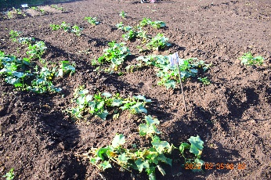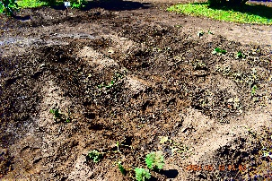
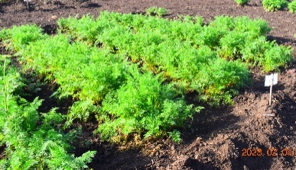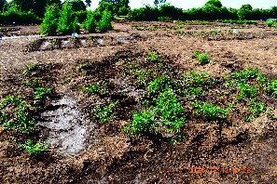
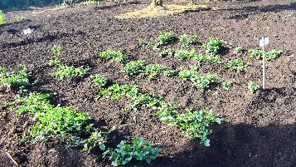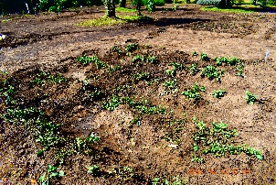
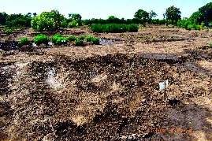
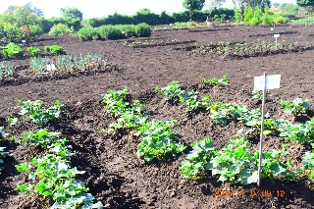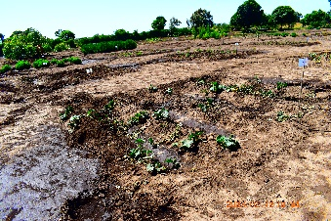
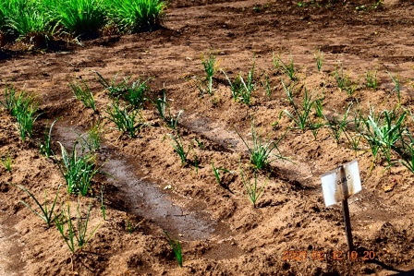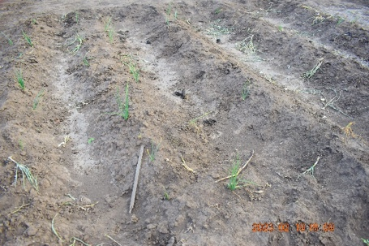

Climate Report
Table 2: 1 MEP’s Experimental Farm Rainfall Recording February 2023
Date Time | Precipitation (ml)  Rain gauge 1 | Precipitation (ml)  Rain gauge 2 (200m² )
2023_02_04 | 5 | 4
2023_02_08 | 5.6 | 4.2
2023_02_09 | 4.6 | 3.4
2023_02_27 | 16 | 10.5
2023_02_28 | 2.5 | 2

Tracking Manager Report
Collared elephants Chelsea and Kiambi were monitored by the MEP mobile ranger team in February. They are navigating an area seeing an increase in infrastructure, causing conflict, and the MEP mobile team is tasked with monitoring their movements and intervening when they venture into community land.

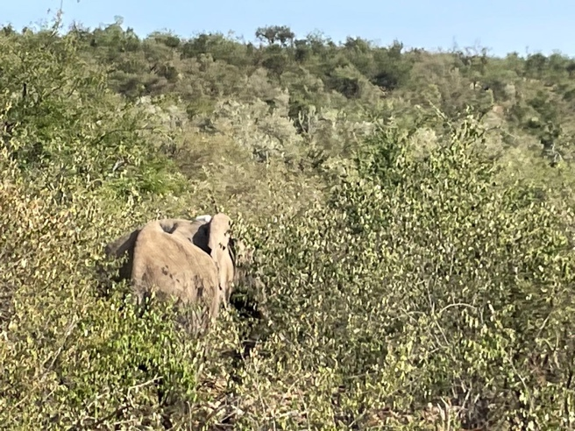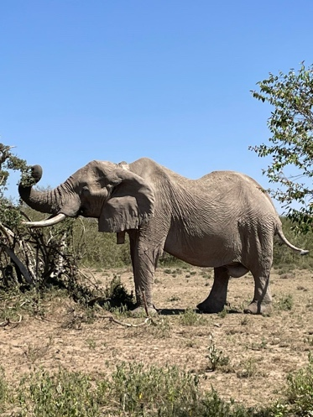

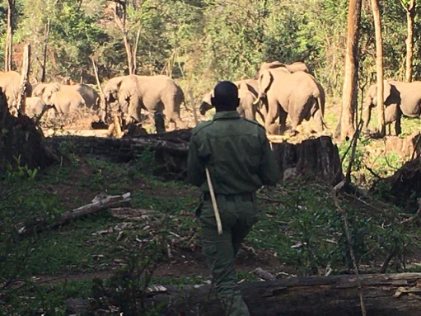
The MEP “Golf” ranger team monitored Fitz and his herd of over 70 elephants inside the Nyakweri Forest in February.

ENVIRONMENT: NDVI
Normalized Difference Vegetation Index (NDVI) is a measure of plant photosynthetic activity. Higher NDVI indicates the plant is greener. The blue trend line shows the current value while the green shaded area shows the min-max range of values centered around the green trend line from values measured back to February 2000.

Greater Mara Ecosystem (GME)
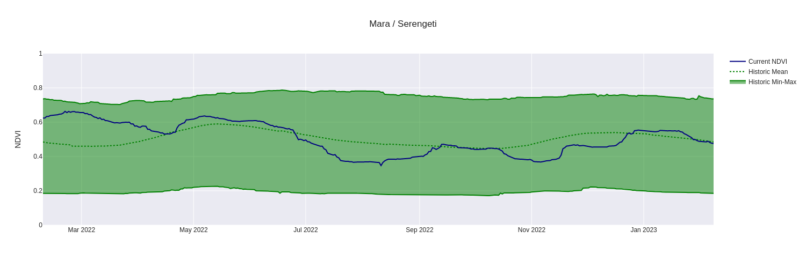
Mau Forest
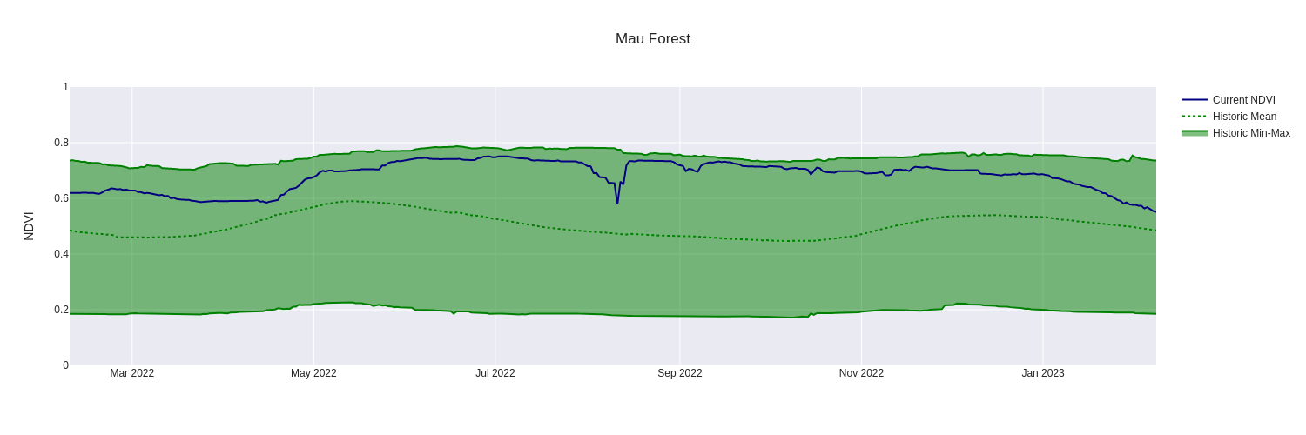
Rift Valley / Mosiro
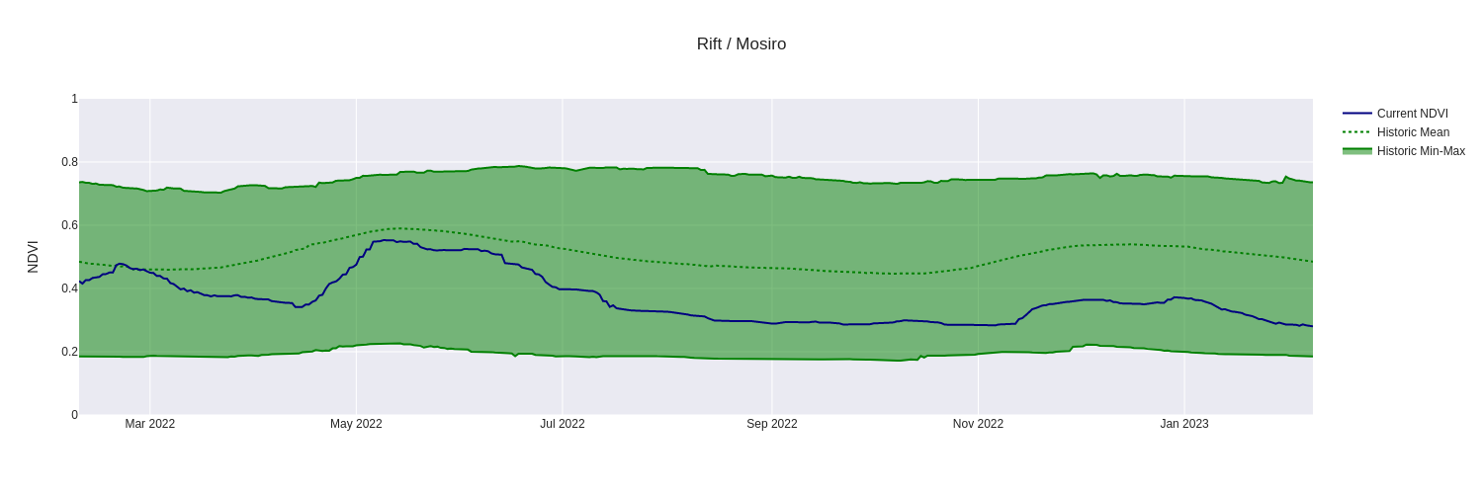
Marmanet Forest
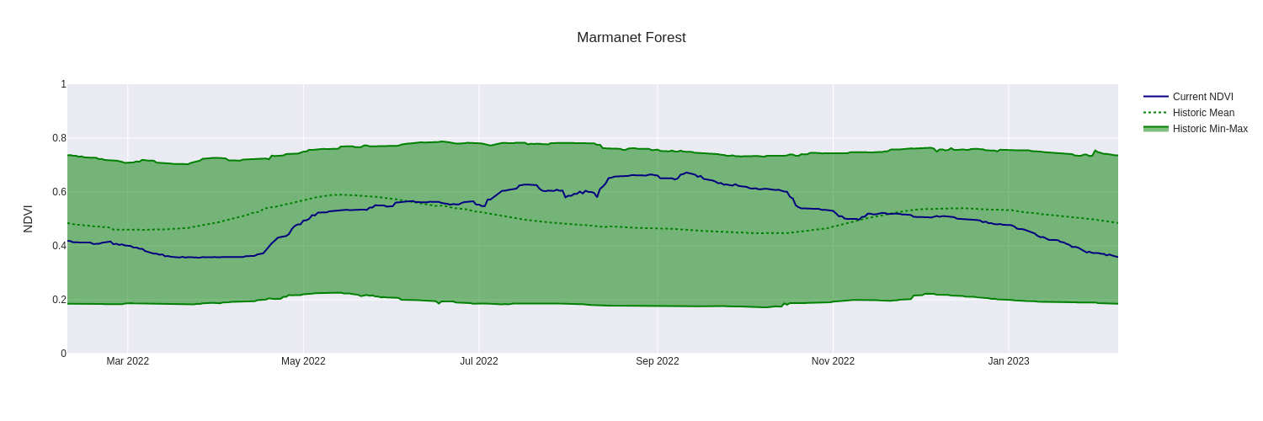

Nyakweri Forest
