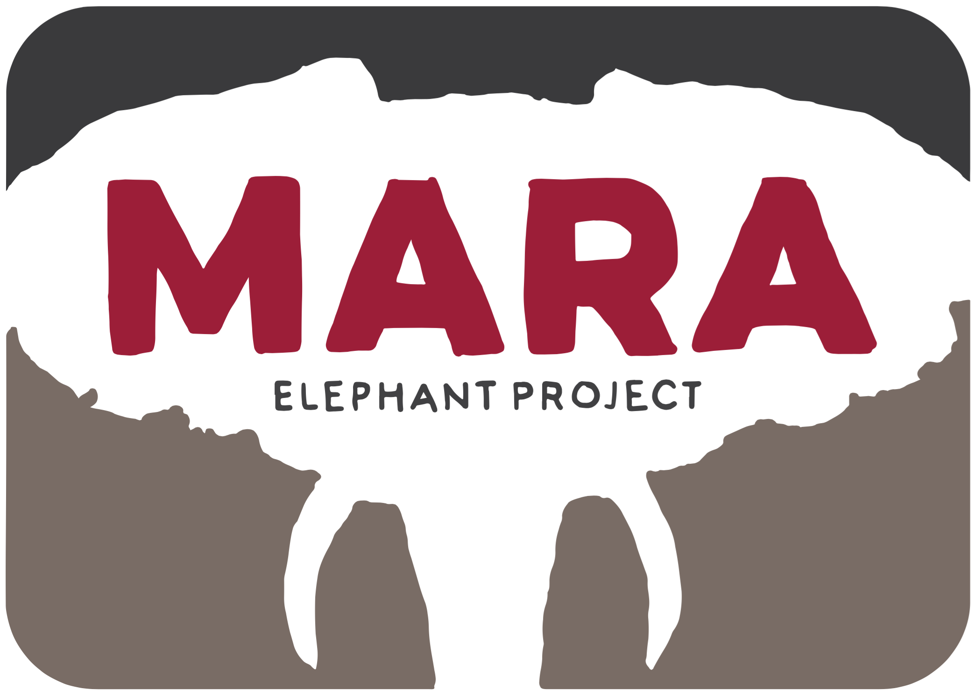
Protect, Conserve, Inspire

Helicopter Report March 2016
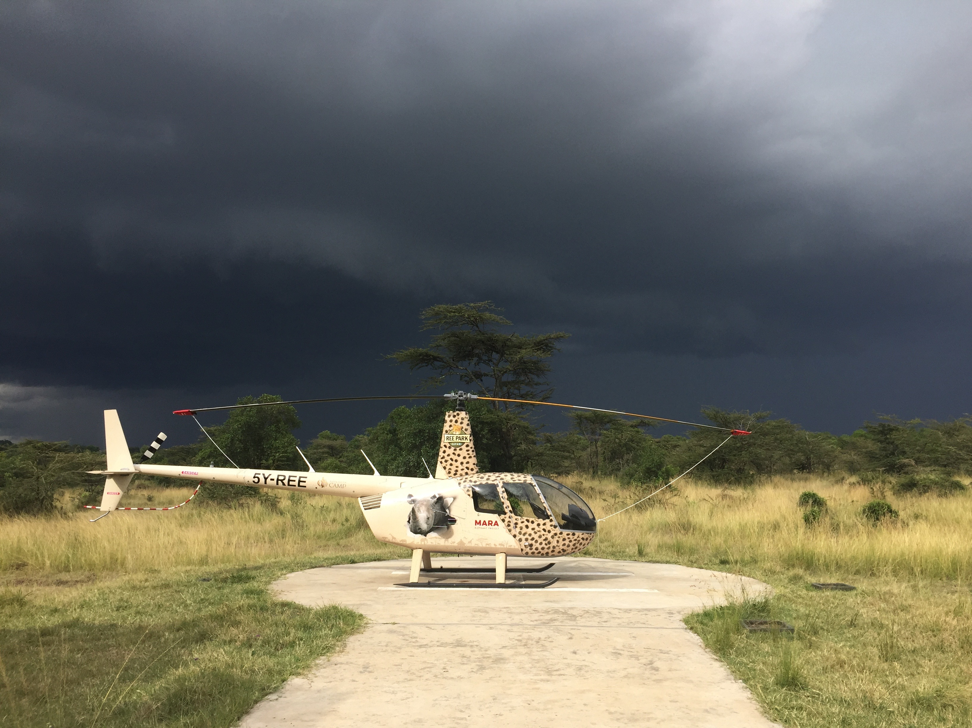

Introduction:
This month the owner of the helicopter Mr. Karsen Ree visited us. This was a good chance to show first hand some of the work we do with this great asset to conservation work in the Maasai Mara. The one concern Karsten had was the hangaring of the helicopter. To this end MEP will try and raise funds to build a hanger at the MEP HQ.

March Situation Report
3/3/16 Ferry | To Nairobi for 100hr Check 1.11hrs
8/3/16 Ferry | Back to Mara via Suswa 1.33hrs
12/3/16 Ele treating | We assisted with aerial support for treating an elephant on Motorogi conservancy who had a swollen vagina 0.82hrs
13/3/16 transport | Collect WWF engineers from Nakuru National Park and take them to Mara. For FLIR installation at Mara Conservancy. 1.4hrs
14/3/16 HEC | Chase elephants away from Mara River where they were crossing into farms. 0.32hrs
15/3/16 HEC | Chase elephants into Ol Kinyei Conservancy from Human Settlements 1.65hrs
16/3/16 Transport | Private transport MG family to balloon safari. 0.4hrs
16/3/16 HEC | Chase elephants out of Mararienta Center 0.8hrs
17/3/16 HEC | Chase elephants out of Mararienta Center 0.31hrs
18/3/16 HEC | Chase Elephants out of Mararienta Center 0.34hrs
20/3/16 HEC | Chase elephants out of farms in Ol Donyo Erinka area. 1.08hrs
22/3/16 REE | To collect Karsten from Nairobi. 1.14hrs
22/3/16 REE | Back to Mara with Karsten via Loita. 1.91hrs
23/3/16 REE | Escarpment visit and recce 0.7hrs
24/3/16 REE | Visit to Ruma National Park and lake victoria. 1.49hrs
26/3/16 HEC | Chase elephants out of Mararienta 0.69hrs
26/3/16 REE | Flight to Ukunda from Mara 3.4hrs
26/3/16 Ferry | MG Flight to Shimba Hills 0.39hrs
27/3/16 REE | Flight to Shimba Hills 0.83hrs
28/3/16 REE | Flight to Funzi sand bar. 0.84hrs
29/3/16 REE | Flight to Nairobi from Ukunda 2.38hrs
Total Hobbs on 29th March 2016 = 134.54
Total hours March: 23.53

Focus for April:
Raise Funding for Hanger
Complete Certificate of Airworthiness in Nairobi

