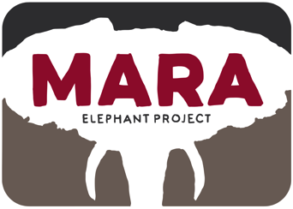
Protect, Conserve, Inspire

Helicopter Report June 2016

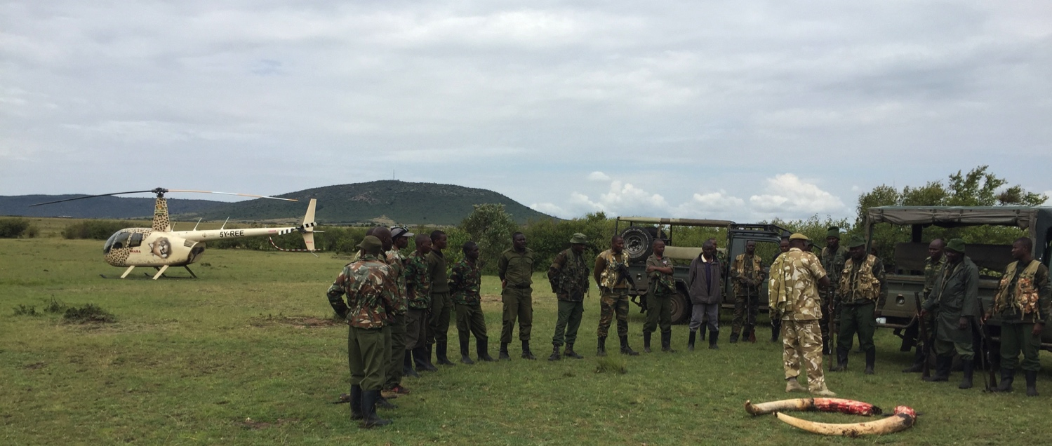
Briefing with KWS, MEP and Conservancy personnel after Bobo’s death.
Introduction:
During June we have tried to publicize the helicopter use more to gather support to pay for flying time and build a hanger on at the MEP HQ. I am happy to report that Ms. Margret McCormick pledged 15,000USD to build the hanger. On Behalf of the MEP team I would like to sincerely thank Ms. McCormick for the generous donation. We will now be able to better look after this very important asset for conservation in the Mara. MEP also put together a case for support for the helicopter which the CEO sent to his mailing list and generated a “indigogo” campaign. So far we have raised 3,500USD. Several individuals have also donated amounts directly to the ESCAPE foundation in the USA.

HEC works remains a major task for the helicopter. The main areas we have been responding to this conflict have been: Munyas area on the northeastern extent of the rangeland. Mararienta Near the Olololo Escarpment. Outside Olkinyei Conservancy. Near Ewaso Ngiro and Olulunga areas. In each of these areas more needs to be done to make sure the elephants do not continue into the crop areas. This means fencing and ground teams also being active to chase elephants. We hope to work more closely with conservancies on the response and precautions to take against HEC. More specifically flashbangs, chili fences, drones, night O.P.’s and noise makers. Then if all else fails the helicopter is called as a last resort to move elephants out of areas.

During this period we have been requested to fly Elephant, Rhino and Giraffe Wildlife Emergency Medical Support (WEMS) missions by the KWS and Narok County Government. Being able to get the KWS vet into the allowed us to treat injured wildlife across the Mara ecosystem. These missions have taught me a lot about some of the more difficult techniques needed to both find and stay with selected animals. KWS Veterinarian Dr. Limo has done some amazing work from the helicopter.

On the 22nd of June we lost elephant Bobo. We deployed 6 rangers at first light to the reported last position. We received several immobility reports from his collaring during the night and we were at the carcass site at 6:30 am. The cause of death was a spear in his stomach cavity from above. It is not clear if he was speared by poachers or angry farmers.

June Situation Report
1/6/16 Transport | CF Flight to Mara. 1.07hrs
2/6/16 Monitoring | Search for elephant Bobo for recollaring. Collar not reporting. 0.67hrs
3/6/16 HEC | Chase elephants and Lions out of Mararienta. 1.26hrs (video)
5/6/16 Transport | Trip to Rusinga Island and back to Mara. 1.84hrs
6/6/16 AST/HEC | Anti Stock Theft and Olkinyei HEC. 0.73hrs
7/6/16 HEC | Move elephants out of farm and back to Ol Kinyei Conservancy. 1.48hrs
7/6/16 Monitoring | Looking for Bobo 1.41hrs
8/6/16 Air Vet and Collaring | Recollaring and treating Bobo. 3.38hrs. (video)
10/6/16 HEC/ Air Vet/ Collaring | Chase Elephants out of Munyas, treating and collaring a wounded Male- Suspected Spear wound. 3.92hrs (video)
13/6/16 Recce | Strategy Meeting Mosiro Area. 1.59hrs
16/6/16 Recce | Check on treated elephants and refuel in Ewaso Ngiro (KWS). 0.98hrs
16/6/16 Recce/KWT | Recce with Matt Rice of the Ol Kinyei, Siana and loita areas. 1.59hrs
17/6/16 Air Vet | Treating Rhino in the MMNR after it had been fighting with another rhino. Treating giraffe near Ololoolo escarpment. 3.25hrs (video)
19/6/16 Recce | Recce Transmara and ranger inspection. 0.93hrs
20/6/16 Recce | Inspection of chili fence, and recce OlKinyei area with Tusk Trust USA CEO. 1.31hrs
22/6/16 QRT/  Collaring | Ranger deployment to Bobo last position. Recollaring Ivy. 5.79
27/6/16 HEC | Chase an elephant out of farms in Transmara. The elephants killed a young man the day before in the same area and the community was very upset. 1.51hrs
28/6/16 Recce | Recce with MEP photographer in Transmara, Aitong , Olkinyei. 1.37hrs
Total Hobbs on 28th June: 207.70
Total May: 34.08hrs

Focus for June:
Start crowd-funding site for hanger and flying time. Secured 15,000$ for the hanger and 4,000$ for flying time.

Focus for July:
Start building hanger
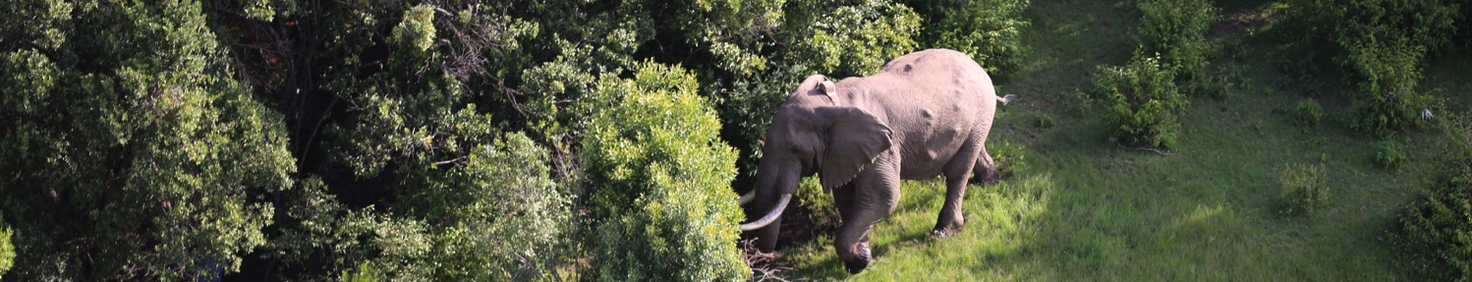
Bobo with several old arrow wounds. Picture taken by Courtney Fehsenfeld the 2nd of June.

Bobo shortly after his death during the autopsy procedure.
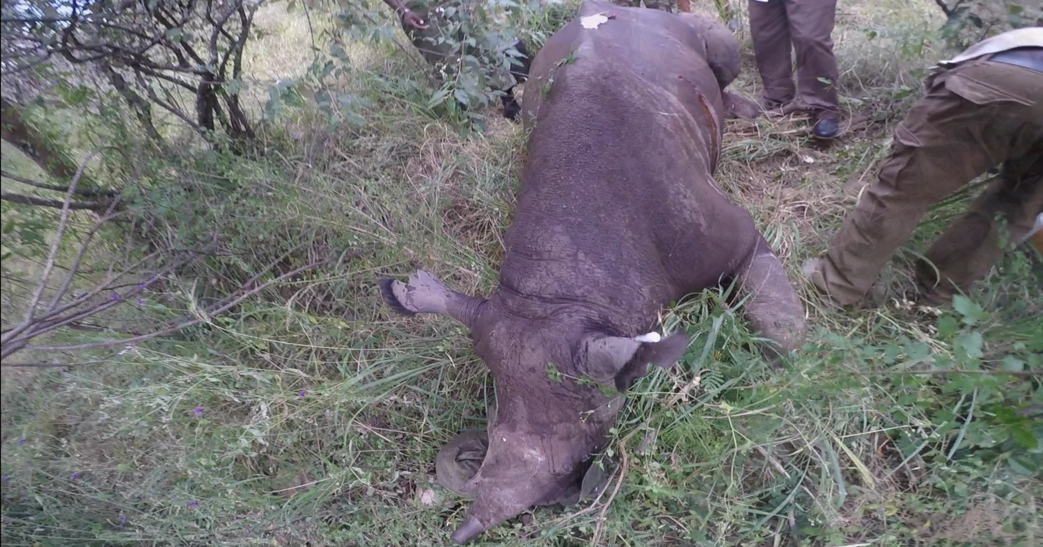Treating a wounded rhino in the National Reserve

