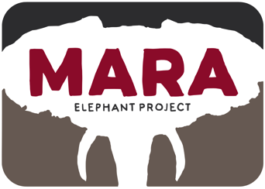
Protect, Conserve, Inspire

Helicopter Report April and May 2016
Collared elephant Lucy and her herd were stranded in farms in the Transmara and we managed to move them back into the forest.

Introduction:
For the month of April the helicopter was at the KWS getting its Certificate of Airworthiness. This was a long process with several delays.

In May KWS and Green Park in Naivasha asked us to move buffalos out of their area. The hot and high altitude flying was good experience-building time for me. The technical flying both included mustering the buffalos though a small area along a fence line and darting and capture.

WWF Kenya requested that MEP tries to locate some of their missing collared elephants. This was somewhat successful and we were able to tune the VHF frequencies and find 1 of the 3 missing elephants. This was also because she came back into signal and we were able to photograph her and her herd inside the MMNR.

Human Elephant Conflict mitigation with the helicopter has become an increasingly important function of the helicopter. In May we responded to a number of incidents. KWS has donated 7 (1400liters) of AVGAS for the aerial recce work in the Mara ecosystem.

April and May Situation Report
1/4/16 Test Flight | Wilson and local area for CoA. Flight maneuvers and systems check. 0.64
28/4/16 WWF | Looking for WWF elephants in Suswa. 1.66hrs
1/5/16 Ferry | Return to Mara 1.3
1/5/16 Transport | Ferry across swollen river 0.25
2/5/16 WWF | Look for WWF collared elephants in the Ol Kinyei Area. 1.21hrs
3/5/16 HEC | Chili Fence inspection Munyas area. 0.41
4/5/16 Monitoring | Visual inspection of elephants Naboisho, Caroline, Fred, Kegol and Hugo 1.09
5/5/16 HEC | Chase elephants out of Munyas area 0.97hrs
5/5/16 WWF | Look for WWF collared elephants in Siana. 2.25hrs
6/5/16 HEC | Search for Lucy and push her out of Tunai farm .58hrs
6/5/16 HEC | Push elephants out of Ewaso Ngiro area into Ollaro area 2.65hrs
7/5/16 WWF | Search for WWF collared elephants in Siana, Mosiro, and Suswa. 3.24hrs
7/5/16 WWF | Return to Mara for Refuel 0.85
9/5/16 WWF | WWF/KWS post collaring meeting in Nairobi. 0.91hrs
9/5/16 WWF | Return to Mara. 1.11hrs
10/5/16 Transport | Trip to Ololomei School. 0.15hrs
12/5/16 Recce | Search for suspect in the Aitong hills. And push elephants from that area to Saruni area. 0.89hrs
14/5/16 Recce | Search for wounded bull elephant in the Siana Area
14/5/16 WWF | Photograph collared elephant Tracey in MMNR 0.73 hrs
14/5/16 HEC | Push elephants out of Transmara farms (video). 0.51hrs
15/5/16 Ferry | Flight to Nairobi MEP meeting 0.87
18/5/16 Ferry/HEC | Back to Mara and push elephants out of Aitong Center (video). 1.81hrs
19/5/16 Capture | Buffalo capture and translocation from Green Park Naivasha with KWS 4.7
20/5/16 Capture | Buffalo capture and translocation from Green Park Naivasha with KWS 4.5
22/5/16 Recce/KWS | Siana Recce with KWS warden Murithi 2.37 (KWS fueled)
27/5/16 SOPs | Teaining Pardamat rangers: Helicopter Standard Operating Procedures. 0.92
28/5/16 Transport | Take Special Consultant to flight. 0.54hrs
31/5/16 Ferry | CF flight to Nairobi 1.23hrs
Total Hobbs on 28th April: 136.87
Total April: 2.33hrs

Total Hobbs on 31st May: 172.39
Total May: 36.75hrs

Focus for May:
Raise Funding for Hanger: Not Done
Complete Certificate of Airworthiness in Nairobi: Done

Focus for June:
Start crowd-funding site for hanger and flying time.

Moving elephants out of Ewaso Ngiro area back to the Ollaro area in Siana.
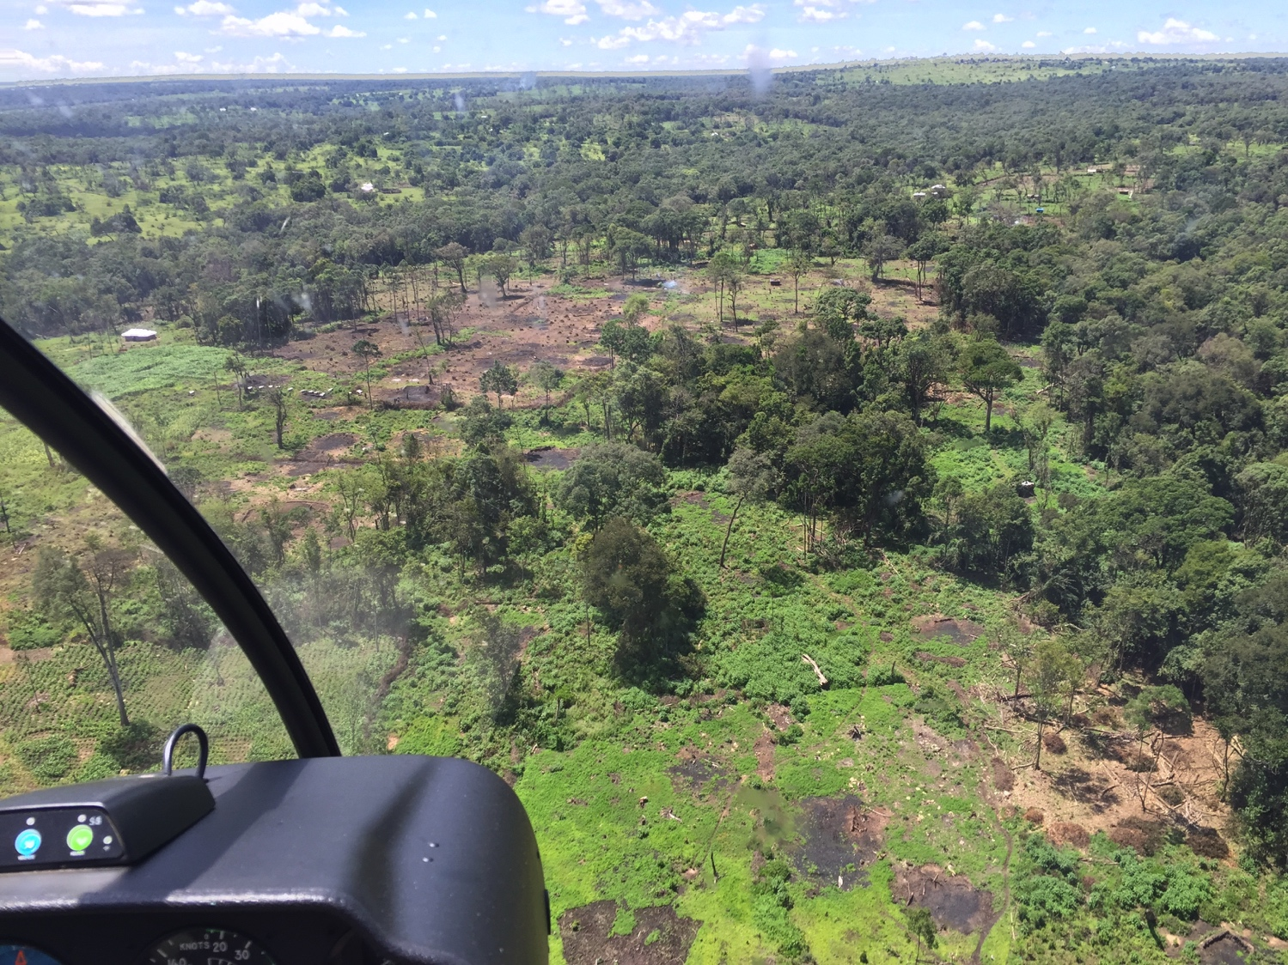
Deforestation in the Nyekweri area continues. Elephant Lucy has been getting into trouble with her herd in this area.

